DATE: 05.10.2018
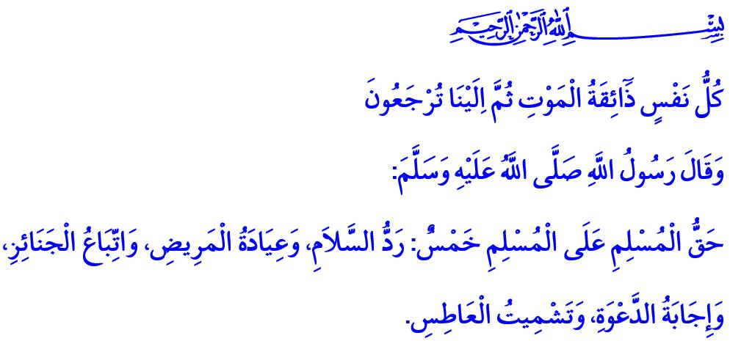
FUNERAL ETIQUETTE: LAST DUTIES FOR THE TRAVELER OF THE ETERNAL LIFE
Jumu’ah Mubarak, Dear Brothers and Sisters!
Our Almighty Lord (swt) states in the verse I have recited: “Every soul will taste death. Then to Us will you be returned.”
Our Prophet (saw) says in the hadith I have read: “The rights of a Muslim on the Muslims are five: to respond to the salam (greeting), to visit when they are sick, to attend their funerals, to accept their invitation, and to wish mercy for them when they sneeze.”
Honorable Believers!
As life is a divine grace, death is an inevitable fact. Every born person will live the life preordained for them, and will eventually die. Death will surely catch every person no matter where they are, no matter how much they try to escape, or no matter how much they try to find a remedy. Although it seems like leaving behind the world, parents, children, and the loved ones; death is actually the name of the reunion of the believing servants with their loved ones in the presence of Allah the Almighty (swt). It is the beginning of a new and eternal life full of peace and happiness for those performing their duty of servitude to Allah (swt).
Esteemed Muslims!
As believers, we have some religious and humanistic responsibilities to fulfill while seeing off our brothers for the Hereafter. Our primary responsibility is not to leave our brother/sister on their deathbed alone, to accompany them till their last breath, and to utter the kalimah al-tawheed aloud to help them breathe their last by acknowledging the kalimah al-tawheed. The Messenger of Allah (saw) says, “Exhort to recite  ‘There is no god but Allah’ to those of you who are dying.”
Honorable Believers!
There is sorrow in the heart and tears in the eyes of the person who loses a loved one. Our beloved Prophet (saw) also shed tears when he lost his son Ibrahim as a baby. But at that moment when he faced with the reality of death which is full of lessons, he (saw) said the following words: “Our eyes shed tears and our hearts are filled with grief, but we do not say anything except that by which Allah is pleased. By Allah, o Ibrahim, we are grieved for you.”
Both death and life are created by Allah (swt). A believer’s part is to submit to the command of Allah (swt) no matter how fresh and great the pain is, without screaming or revolting; and to hope to meet in heaven inshaallah, and asking patience from Allah. Belief in our Almighty Lord’s divine address of  “Indeed we belong to Allah, and indeed to Him we will return.”, is cure to the pain of hearts, and a remedy for the longing of hearts.
Honorable Muslims!
One of the arrangements to be made for a deceased person is called “tajhiz and takfin”, which includes the washing and enshrouding the body, performing the funeral prayer (salat al-janazah), and burial. When a person passes away, their relatives, friends, neighbors and other Muslims are informed. The body is washed and enshrouded carefully with due attention to privacy. The closest relative or suitable persons who are appointed by the closest relative attend the washing of the body. If the deceased person has outstanding debts, their debts should be paid off, by funeral prayer if possible, from the property left behind, and their bequest, if any, should soon be realized.
Honorable Believers!
Another religious responsibility for us is to attend the funeral prayer of our deceased brother/sister and pray Lord Almighty (swt) to forgive him/her while leaving off the mortal world for the eternal life. The Messenger of Allah (saw) said, “When you perform funeral prayer, make a sincere supplication for the deceased.”
Sorrows decrease when shared. Being a brother in religion requires condoling with the deceased person’s relatives and wishing them patience and fortitude. Condolences should not be delayed, and any word or behavior to hurt the deceased’s relatives should be avoided. Our beloved Prophet (saw) says, “Make a mention of the virtues of your dead, and refrain from (mentioning) their evils.”
Esteemed Believers!
It is not appropriate nor expected of mourners who are in grief of their loss to be further bothered and busied by the preparations of food for people coming to deliver their condolences. It is the Sunnah of our Prophet (saw) that the neighbors and relatives prepare and offer food for the mourners and their guests. As a matter of fact, hearing the news about His cousin Ja’far’s martyrdom in the Battle of Mu’tah, our beloved Prophet (saw) said, “Prepare some food for the family of Ja’far, for indeed something has happened to them that will keep them busy.”
Valued Muslims!
The Beloved Messenger (saw) says, “Frequently remember ‘the destroyer of pleasures’, meaning death.”.
Death, then, has a language that preaches, teaches, and warns. Funeral ceremonies function not only as an opportunity to pray for the deceased, but also to look at ourselves and review our lives. One day we will run out of our life-span capital, and each one of our deeds, no matter how small, will get their reward.
We as believers have always husn adh-dhann (good assumption) about our Lord (swt). We expect His forgiveness, mercy, and compassion. We believe that death will leave the hope of eternal spring to our faithful hearts. While so, we also endeavor to stay on the straight path of Islam and strive to live our lives with integrity. Only then becomes death a greeting, from Allah (swt), of eventual meeting with Him and a door opening to the realm of everlasting peace.

‘Ankabut, 29/57.
Bukhari, Jana’iz, 2.
Nisa, 4/78; Jumu’ah, 62/8.
Muslim, Jana’iz, 2.
Muslim, Fadhail, 62.
Baqarah, 2/156.
Abu Dawud, Jana’iz, 54, 56; Ibn Majah, Jana’iz, 23.
Abu Dawud, Adab, 42; Tirmidhi, Jana’,z, 34.
Tirmidhi, Jana’iz, 21.
Nasa’i, Jana’iz, 3. General Directorate of Religious Services

